**Technologies**

* Carry out research on the internet.
* Create a powerpoint with information found.
* Use the internet to carry out specific tasks.
* Create a 3D model of a mining system.
* Look at modern mining machinery to compare to past.

**Experiences and Outcomes - Social Studies/Sciences/Technologies**

* Having explored the landscape of my local area, I can describe the various ways in which the land has been used. SOC 1-13a
* I can explain how the physical environment influences the ways in which people use land by comparing my local area with a contrasting area. SOC 2-13a
* I can describe the major characteristic features of Scotland's landscape and explain how these were formed. SOC 2-07a
* I can discuss the environmental impact of human activity and suggest ways in which we can live in a more environmentally friendly way. SOC 2-08a
* I can use evidence to recreate the story of a place or individual of local historical interest. SOC 1-03a
* I can use primary and secondary sources selectively to research events in the past. SOC 2-01a
* I can investigate a Scottish historical theme to discover how past events or the actions of individuals or groups have shaped Scottish society. SOC 2-03a
* Having explored the substances that make up Earth's surface, I can compare some of their characteristics and uses. SCN 2-17A
* I am aware of different types of energy around me and can show their importance to everyday life and my survival. SCN 1-04a
* Through exploring non-renewable energy sources, I can describe how they are used in Scotland today and express an informed view on the implications for their future use. SCN 2-04b
* I can access, retrieve and use information from electronic sources to support, enrich or extend learning in different contexts. TCH 1-03b
* Throughout all my learning, I can use search facilities of electronic sources to access and retrieve information, recognising the importance this has in my place of learning, at home and in the workplace. TCH 2-03b.
* I can investigate the use and development of renewable and sustainable energy to gain an awareness of their growing importance in Scotland or beyond. TCH 2-02b

**Key Website**

http://www.scottishshale.co.uk/SchoolsPages/SchoolsIntroduction.html

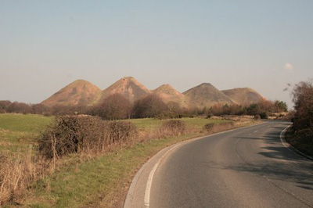 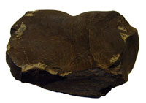

**Shale Oil Industry**

Topic Plan

First/Second Level

**Health and Wellbeing**

* Investigate the ill effects on health of miners.
* Create a keep safe poster with ideas to stay safe.
* Look at diet from then and compare to diet now.
* Create a poster on activities to do after work to relax or feel happier - contrasting long hours in a mine.

**Numeracy**

* Compare the currency from then and now.
* Use currency to work out wages.
* Compare hours worked to school hours.
* Use weights to work out how much would be mined.
* Use volume to look at volume of oil from oil shale.

**Social Studies**

* Investigate famous inventors/scientists involved in shale oil.
* Look at photos of artefacts and investigate their job.
* Compare past and present photos of West Lothian and how it has changed.
* Complete a local environment study of their home/school/West Lothian looking at landscape, features, jobs.
* Look at impact mining has on environment, above and below surface.

**Expressive Arts**

* Use charcoal to create a picture of a miner or mining scene.
* Look at images of open-cast mining and artscape - create own.
* Act out jobs from mining (charades)
* Look at music from 19th and early 20th century - compare to modern music.

**RME**

* Investigate ages of churches in West Lothian and how close to miners villages - consider their use in that time.

**Science**

* Look at properties of different rocks especially coal/sedimentary.
* Investigate fossil fuels and future impact.
* Investigate energy consumption and production.
* Contrast fossil fuels with green energy.
* Carry out experiments with different viscosity of liquids.

**Literacy**

* Create a newspaper report about an accident in the mines.
* Create a job advert.
* Read for information from website.
* Read transcripts and write a diary entry for that person.
* Listen to a transcript and answer questions.
* Create a factfile about a famous inventor/scientist.